Mitchell Humphries

Potential Well analysis by Second Order Runge Kutta

Topic – 2

California Polytechnic University, Pomona

**Abstract - In this paper, the motion of a particle trapped in three unique potential wells was studied. These wells include a double-well potential, a square/inverse-square potential and a quartic/inverse-square potential. Several commonly sought-after attributes of the motion of the particle were investigated. These included the frequency of oscillations, total energy, and in the presence of a dampening and driving force, the change in the frequency and change in amplitude. These attributes were determined for a variety of staring positions, and at different energy levels, then compared to investigate trends that would appear within the system.**

The motion of a particle trapped in a potential-well is a common question asked in several fields of physics. For this investigation, the motion of a particle was investigated for three unique wells. These potential wells were defined as:

Potential 1: $U_{1}=2π^{2}(\frac{x^{4}}{4}-\frac{x^{2}}{2}+\frac{1}{4})$

Potential 2: $U_{2}=π^{2}(\frac{1}{{2x}^{2}}+\frac{x^{2}}{2}-1)$

Potential 3: $U_{3}=\frac{{2π}^{2}}{3}(\frac{1}{{2x}^{2}}+\frac{x^{4}}{4}-\frac{3}{4})$

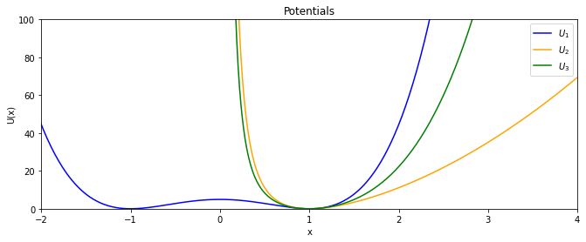

Figure 1

As seen on figure 1, potential 2 and potential 3, have a single minimum and thus equilibrium position for a particle. For potential 2 and potential 3, this minimum is located at x = 1. However, for potential 1, there is two equilibrium positions. These points occur at x = -1 and x = 1. Due to this potential 1 is said to have local wells at these positions. Due to the symmetry of the graph about x = 0 trends that occur within one local well would occur in the other. For this reason, investigations of the local well of potential 1 were done at x = 1.

To determine the motion of the particle within the potential wells, the mass of the particle was taken to be 1 in all examples. Furthermore, for all examples initial velocity was set to zero. This allowed for the equation of motion to be determined as $F= \frac{-δU}{δx}$. This resulted in the fallowing equations of motion.

Potential 1: $F_{1}\left(x\right)=-2π^{2}x(x^{2}-1)$

Potential 2: $F_{2}(x)=\frac{{-π}^{2}(x^{4}-1)}{x^{3}}$

Potential 3: $F_{3}(x)=\frac{{-2π}^{2}(x^{6}-1)}{{3x}^{3}}$

With these equations of motions the 2nd order Runge Kutta method can be applied. Upon doing so the position of the particle, the velocity, and energy can be observed. With a starting position chosen to be x = 1.42

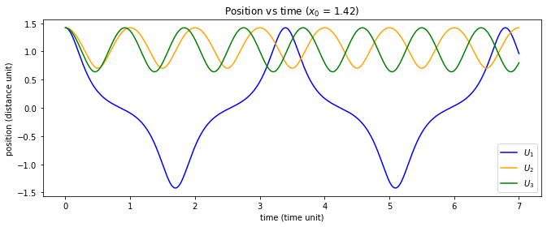

Figure 2

As figure 2 shows, for potential 2 and potential 3 the particle is bounded to positive values. However, potential 1 can travel over the local maximum of the potential located at x = 0 and thus be located at values less than zero. Using the velocities from the 2nd order Runge Kutta method the velocities oscillation can also be observed.

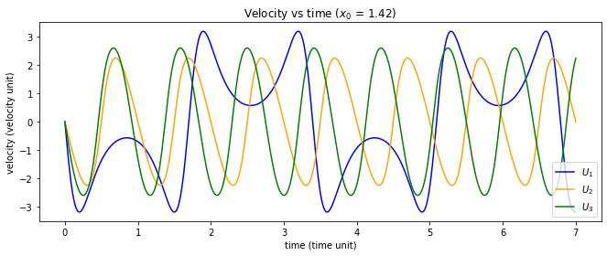Figure 3

Once again, a particle trapped in potential 2 and potential 3 behave in a similar manner. They both fluctuate their velocities between approximately -2.8 and 2.8. A particle in potential 1 has a unique oscillation pattern. This is due to the local maximum that makes the velocity temporarily decrease during each oscillation. As the velocity does get close to zero, it is known that the particle has just enough energy to clear this local maximum.

As the velocity and mass of the particle is known, the kinetic energy is also known by the equation $Ke=\frac{1}{2}mv^{2}$. The potential energy is then simply calculated by using the position of the particle and the potential well equations. By combing these values, the total energy of the particle can be plotted against time. 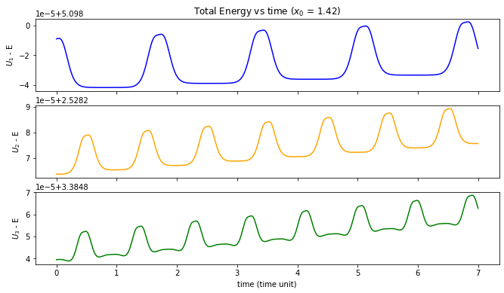

Figure 4.1, 4.2, 4.3

Despite this system being conservative, figure 4 shows that the energy fluctuates on the order of ${10}^{-5}$ for all three potentials. This fluctuation is due to the limits of the 2nd order Runge Kutta method. The 2nd order Runge Kutta method does not accurately approximate the velocity at high gradients. Due to this it is seen that when the particle is under large acceleration energy is not conserved. For this reason, all testing was performed at initial values less then x = 5. At times when the particle is not under large acceleration energy is closer to being perfectly conserved. Despite the small energy drift, the 2nd order Runge Kutta method still provides satisfactory results and can be used when determining period, frequency, and the energy of a particle oscillating within the three given potential wells.

Using this approximation, the frequency was determined for different starting positions within the three potentials. This was achieved by first using the 2nd order Runge Kutta to approximate the particles position. Applying a Fourier transform to the position, the fundamental frequency was able to be determined for the oscillation.

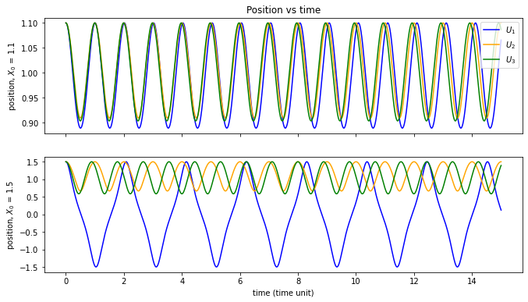Figure 5.1, 5.2

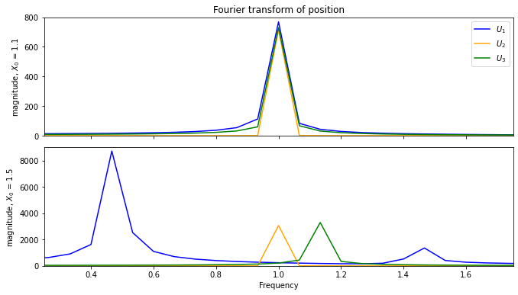figure 6.1, 6.2

Using an initial starting value of x = 1.1 it is immediately seen, from figures 6.1 and 5.1 that the particle will oscillate in all three potentials wells at a frequency of approximately 1, thus with a period of approximately 1 as well. This is known by observing the peaks of the Fourier transformation of position, on figures 6.1 and 6.2. The first occurring peak of the Fourier transformation is the fundamental frequency of the particle’s oscillation. It is important to note that the oscillation for potential 1 occurs in the local potential well at x = 1. An oscillation of the same magnitude would yield the same frequency and period if it occurs at the local potential well located at x = -1 as explained previously. This then leads to the 1st observation statement:

Observation 1: For all three potentials, a particle starting near equilibrium oscillates at a frequency of 1, and therefore a period of 1.

Upon moving the starting distance far from the equilibrium position of x = 1, to a new location of x = 1.5, new frequencies are obtained for a particle oscillating in potentials 1 and 3. For potential 1 it is immediately clear the particle is no longer oscillating in either of the local minima but, instead oscillating across the entire potential well. This is known as the particle travels across the local maximum located at x = 0, as seen on figure 5.2. Figure 5.2 also shows that a particle in potential 2 does not experience a change of frequency and instead remains at 1. These observations can then be combined to form the 2nd observation statement:

Observation 2: For a particle starting far from equilibrium, the fundamental frequency changes for potentials 1 and potential 3.

For all three of the potential wells, it can be reasoned that any change to the starting position of a particle, will lead to an increase in the total energy of the particle. This is because for all three potential wells the equilibrium position has a value of zero. Due to this and Observation 2, it can be reasoned that an increase in the total energy of the system will lead to a change in the fundamental frequency of a particle in potential 1 and potential 3.

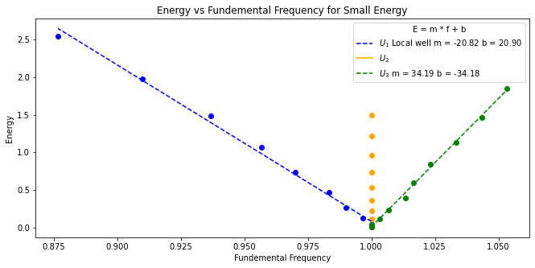

figure 7

A small original staring value of x = 1.01 was used, this was used to keep the total energy values low. Due to the small energy values the particle in potential 1 was then bounded in the local well located at x = 1. The starting position was then increased to 1.31 in 10 even steps. This then revealed that for a particle in potential 1 and potential 3, the relationship between the total energy of the system and the frequency of oscillation is of the form: $E=m*f+b$, as shown by figure 7. Where E is the total energy, f is the fundamental frequency, and the two constants m and b are dependent on the potential. A particle in potential 2 did not experience any significant change in frequency with an increase in energy. This was expected as potential 2 is not included in Observation 2. This then leads us to a new observation statement.

Observation 3: For a particle oscillating in potential 1 and potential 3, at small energy values, a change to the total energy is proportional to the change in the fundamental frequency.

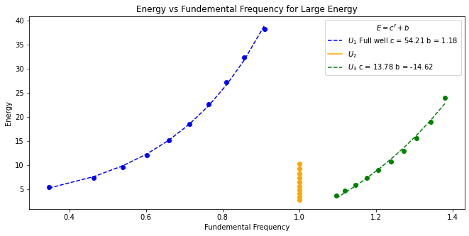

figure 8

Next, a larger value of x = 1.43 was used. This was to create particles which would have much higher energy. As shown by figure 8, at higher energies, the total energy and the fundamental frequency are no longer proportional for either a particle in potential 1 or a particle in potential 3. Instead they are now related by an exponential relationship. Thus, the best fit equations are of the form: $E=c^{f}+b$. Where E is the total energy, f is the fundamental frequency, and the two constants c and b are dependent on the potential. This is now the basis for the 4th observation statement:

Observation 4: For a particle oscillating in potential 1 and potential 3, at large energy values, a change to the total energy of the particle, is exponentially related to the fundamental frequency.

For both small and large energy amounts a particle oscillating in potential 2 did not experience any significant change in frequency. This then leads directly to a 5th observation statement:

Observation 5: For any energy value, a particle oscillating in potential 2 will keep the same fundamental frequency of 1.

As previously mentioned, the total energy of a particle in the system is equal to the energy from the potential and the kinetic energy from the particles motion. For a particle to have kinetic energy it must not have started at the equilibrium, and therefore be oscillating in the potential well. Thus, the total energy of the system, for low energies, should be related to the difference between the expectation value of position and equilibrium.

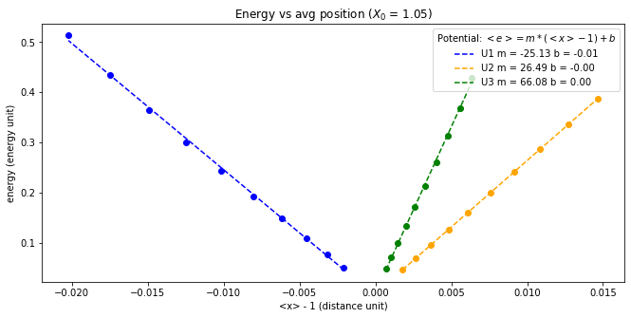

figure 9

Figure 9 shows a pot of the total energy of the system, and the expectation value of position minus 1. As seen the relationship is of the form: $E=m*(<x>-1)+b$. Where E is equal to the total energy of the system, $(<x>-1)$ is the positional expectation value minus 1, and the two constants m and b are dependent on the potential. Further adding to validity of this relationship is that for all three potentials, the constant b is approximately zero. This is as expected as if the particle stats at equilibrium, all three wells provide zero potential. This then allows a 6th observation statement:

Observation 6: At low energies, for all three potentials: $<x> - 1 α E$

Observations can also be made about how the motion of a particle will behave if a dampening and driving force is added. To do this, all three equations of motions were altered in the same manner as follows:

$$G(x)=F(x)-V\left(x\right)*γ+ F_{0}cos⁡(wt)$$

Where G(x) is the new dampened and driven equation of motion. F(x) is the original equation of motion for the particles in each potential. $γ$ is the damping constant, $F_{0}$ is the driving force, and w is driving frequency. Using these new equations of motion, it becomes possible to plot the oscillation of a particle with a dampening constant and, plot the oscillation while both a dampening and driving force are applied.

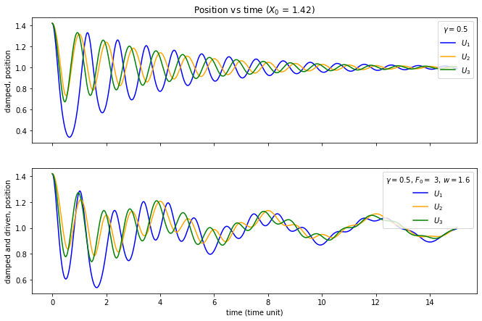figure 10.1, 10.2

As seen in figure 10.1, applying just a dampening force lead to a decrease in the oscillation’s amplitude which decays to zero. While applying both a damping and a driving force leads to a new steady oscillation. This allows for a decay to half max amplitude to be determined, for a particle oscillating in any of the potentials. Which can then be related to the decay constant. To do this the time to decay to half the max amplitude was taken to be the time at which a peak occurs, that is less then or equal to half the staring amplitude.

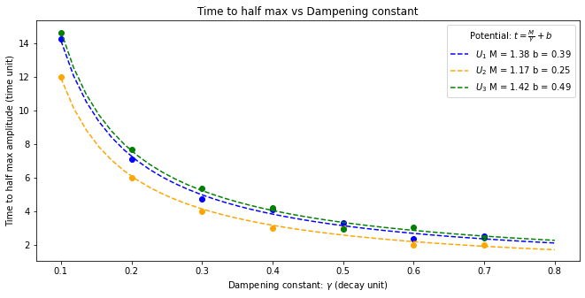

figure 11

As demonstrated in figure 11, the time to reach half max amplitude is related to the dampening constant with the form of the relationship as: $t= \frac{M}{γ}+b$. Where t is the time to half max, $γ$ is the decay constant, and the two constants M and b are dependent on the potential. This then leads to a new observation.

Observation 6: The time in which it takes a particle oscillating in any of the three potentials, to decay to half its original amplitude is inversely proportional to the decay constant.

For a particle in a potential well, which is under a dampening and driving force, the oscillation does not stop as it would if it were only damped. Due to this by adding a dampening and driving force to a particle oscillating in any of the potential wells it can be reasoned that after a given time, the new steady oscillation will have a relationship with the driving frequency and the driving force.

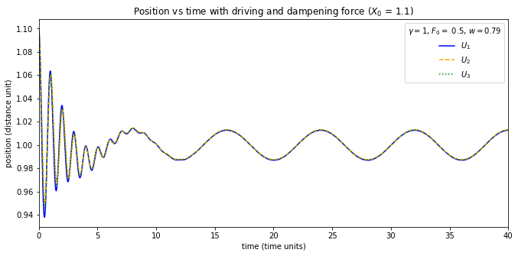figure 12

As seen in figure 12, under the influence of a damping and driving force, the particle undergoes complex motion then quickly settles into a steady oscillation. The period then is determined by the difference in time between peaks on figure 12.

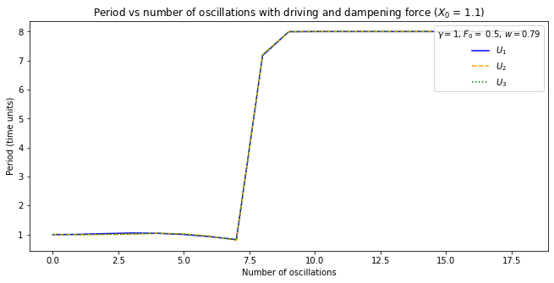

figure 13

Figure 13 shows the period vs the number of complete oscillations. A complete oscillation was taken to be the time between a change in the direction of motion from positive to negative. Figure 13 shows that the period stabilizes at a value of 8. This is expected as the period of a driven oscillator is related to the driving frequency by the relationship: $Period= \frac{2π}{w}$. In this case a driving frequency of $\frac{π}{4} ≈0.79$ was used. This results in an expected value of $2π*\frac{4}{π}$. Which is equal to the expected value, from figure 13 of 8. This leads to a new observation:

Observation 7: Under the influence of a driving force, a particle in any of the three potential wells, will reach a state of steady oscillation where the period is related to the driving frequency by: $Period= \frac{2π}{w}$.

Not only is the period related to the driving frequency, the amplitude of the steady oscillation is related to the driving force. Similar to how the period can be determined from investigating the peaks of figure 12, the amplitude of the steady oscillation can be determined by investigating the position of the particle at the last, and thus most steady, peak of figure 12 and subtracting the equilibrium position.

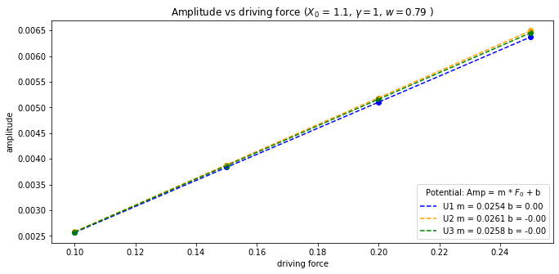figure 14

Figure 14 shows the relationship between the amplitude of a steady oscillation and the driving force. This relationship is of the form: $Amp=m*F_{0}+b$. Where Amp is the amplitude of the oscillation, $F_{0}$ is driving force, and the two constants m and b are dependent on the potential. This leads to the final and 8th observation statement:

Observation 8: Under the influence of a driving force, a particle in any of the three potential wells, will reach a state of steady oscillation where the amplitude is proportional to the driving force.

As demonstrated the 2nd order Runge Kutta method allowed for the study of a particle oscillating in three unique potential wells. It was determined that for a particle starting close to the equilibrium in any of the three potentials the particle would oscillate at a frequency of 1. However, moving far from the equilibrium positions resulted in a change of the frequency of oscillation for the particles in potential 1 and potential 3. A particle in potential 2 continued to oscillate at frequency of 1. It was then determined that the change in energy was responsible for the change in frequency of a particle in potential 1 and potential 3. Despite the unique behavior of a particle in potential 1 and potential 3, it was also observed that for a particle in any of the three potentials: $<x> - 1 α E$. By altering the equations motion, a dampening and driving force were added. In the presence of only a dampening force it was determined that the time to decay to half the original max amplitude is inversely proportional to the dampening constant. Lastly, it was determined that if a particle in a potential well is under the influence of both a dampening and driving force, after an initial period of complex motion, the particle moves to a state of steady oscillation with: $Period= \frac{2π}{w}$, and an amplitude which is proportional to the driving force. Despite the limits of the 2nd order Runge Kutta method, the use of it to simulate a particle trapped in a potential well yields satisfactory results which can be used to observe many attributes of the system as shown.